The Parish Magazine of St Nicholas with All Saints, Wallasey
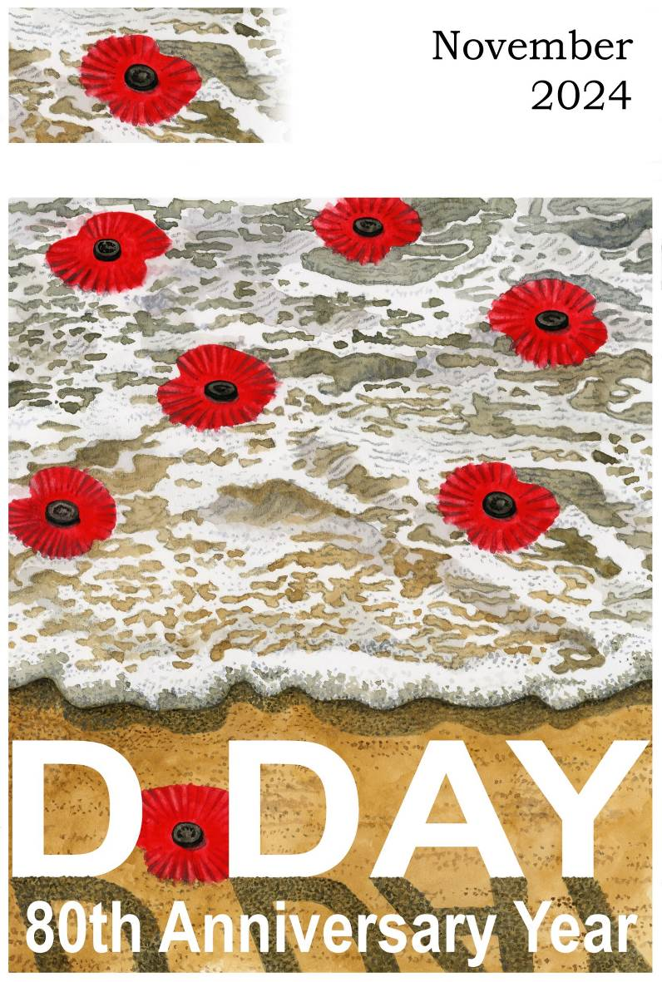
price 50p


NOVEMBER 2024

Sunday 3rd 4th before Advent – All Saints Sunday

9.00am BCP Holy Communion
10.00am CW Holy Communion
Wednesday 6th 10.30am Service in The Lady Chapel

Sunday 10th 3rd before Advent Remembrance Sunday (BCP 24th after Trinity)
9.00am BCP Holy Communion
10.00am CW Morning Prayer
Monday 11th. 10.45am Act of Remembrace in Church.
Wednesday 13th 10.30am Service in The Lady Chapel

Sunday 17th 2nd before Advent (BCP 25th after Trinity)
9.00am BCP Holy Communion
10.00am CW Holy Communion

Wednesday 20th 10.30am Service in The Lady Chapel

Sunday 24th Christ the King (BCP Sunday Next before advent)

9.00am BCP Holy Communion
10.00am CW Morning Prayer

Wednesday 27th 10.30am Service in The Lady Chapel


The Vicar writes…… November arrives.

The first Sunday of November marks the celebration of All Saints. The celebration of All Saints should be a great occasion for all churches, but especially so for us who carry the Parish title of Wallasey St Nicholas with All Saints. I still remember with great fondness the evening of my licensing to, what was then, the United Benefice of Wallasey St Nicholas with All Saints held in All Saints. Little did I know as I walked down the aisle in the starting prcession what lay ahead just and hour or so later when a little group from All Saints congregation called me aside and said “Now that your in charge, you need to know of a little problem…..” Ha Ha, welcome…

Celebrating All Saints Sunday allows us to remember those who served the church faithfully over many years but who have now entered into their rest. Obviously we think back to those first apostles who stepped out in faith to preach the gospel, even unto death. But we also think of those who set the foundations of the parish we have inherited. We must recognize the hard work done by the faithful who maintained the church and kept the faith alive during some incredibly difficult periods in the life of our nation, and this community. Looking back at that faithful stewardship of the church should be a great encouragement and inspiration to us. Being a light for Jesus can be both a joy and a burden, thus it has ever been. But whether we are going through good times or hard times, we must trust ourselves to God and do the work he has set before us, just as those who have gone before have done.

Then we celebrate Remembrance Sunday. Again, as with All Saints, we look back, only this time it is to remember those who gave their lives defending freedom generally, and this nation particularly. The main focus is on the WW1 of course, but we must also remember WW2 and all the other wars that have been fought, and are still being fought to this very day, where the loss of life of both military personnel and civilian population is tragically high. Sadly, all of us are living under the threat of another great conflict with China, and Russia flexing their muscles and using their military might to destabilize the world. Add to that the tensions of the Middle East and the desire of the extremists in both North Korea and Iran to undermine Western values and we have a very complex and difficult period of time to navigate through. We need to pray that voices of peace, reason and tolerance speak louder than the voices of hatred.

Then onwards to the celebration of Christ the King. This celebration marks the end of the Christian Year. All that has gone before, of which the starting place is Christmas, has pointed us to towards reaching the conclusion that ‘Jesus is the King’ as foretold by the Magi. It is a triumphant end to the Christian year as we recognize that all that is promised at Easter (victory over death and the hope of resurrection life) is possible because Jesus is actually sovereign ruler of all things, and the one through whom all things are created and have their being. Christ the King then leads us into Advent, a season when we look forward to a time when the King will return and bring all things under his control, the moment when the new heaven and new earth are brought to be. Yes Advent is a season that speaks of judgement but for those who receive Jesus as Lord and King there is no fear of that judgement for we will receive the goal of our faith, an inheritance that will never spoil or fade, eternal life. Advent concludes, of course, with the start of the story that tells us how hope came into the world, the birth of Emanuel, God with us, and off we go again….. but more about Advent next time. For now, let’s enjoy all that November brings to us, to the glory of God, Father, Son, and Holy Spirit. Amen.

Jeff x.


CHOIR NEWS
Well believe it or not we have started to learn our songs for the Christmas Concert! If anyone reading this would like to be involved, please let me know or just come along to choir practice in church on Thursdays at 6.30pm start. Its so great to sing together as a choir every week but our special occasions such as a super concert is also a lovely experience! Lots of special services also over Remembrance weekend and then Christmas that we are involved in too.

The St Nicholas Christmas Gala Switch-On Concert for the start of the Christmas Tree Festival, is on Sunday 15th December at 4.00pm. Tickets limited to 200 so hurry and reserve or buy yours now! Just £10 each with the Allerton Brass Band playing a wonderful range of music. What a great way to start your Christmas Festivities than a brass band at Christmas. Come in your Christmas Jumpers!


The Christmas Tree Festival 2024
Let’s make this the best festival we’ve had! Please consider having your own tree or paying for one to be decorated for you. The trees are costing £30 for a 4ft tree, other sizes will be available too but will cost slightly more. Any clubs, businesses and shops that you have a connection with....ask them if they’d be interested in being part of this wonderful festival. The more the merrier and the church will look stunning with the trees lit up. Speak to Elizabeth Brandwood or Gill Hazlehurst or Jeff. Thank you.

CHURCH CLEANING IN NOVEMBER – Saturday 16th November from 9.00am
Please consider coming along to help clean our beautiful church. It regularly needs polishing, cleaning, hoovering, tidying and sorting out. We have plenty of brushes, cloths and polish for you to use. We usually only take about an hour depending on how many. We finish with tea, coffee and toast. It’s a great opportunity to chat with friends from church too!

Helping the Needy The Ark
Thank you for your Harvest donations this year which was an incredible amount of things. Forum Housing were overwhelmed with our generosity.
This month we are helping The Ark with donations of Christmas Mugs. They will fill them will Christmas goodies for the folk who visit them. Also think donations of socks, gloves, hats and scarves will be gratefully received too. Thank you.


Breakfast with Santa – Saturday 21st December 9.30am
This is limited to 20 tickets so you need to be quick ordering them! £5 each. We welcome you at the front doors then you go into the church and have a story by the font. Into the sanctuary for another story, then into the vestry to wake up Santa! Toast and juice with Santa and sing some fun Christmas Songs. Santa gives the children a gift then you can look at all the lovely trees. Adults are free with a child!

Jack & The Beanstalk Panto in January
There is still time if you would like to be part of our chorus. It’s great to be involved and have such a fun-time! We practice at the hall on Tuesdays from 6.30pm.

Sending thanks……

The family of Sylvia Gartland would like to thank everyone for their kind words of sympathies, cards and flowers. So many of you came to the Celebration of Sylvia's Life Service too and we were all so delighted to see you all and so many of you going to the trouble of wearing a " Touch of green" ! She would have been thrilled ! We've planted a small pink rose bush near the front door in my mum's memory.
Thank you once again for all your support, love and prayers xx

St Day Celebration & Toy Service

Sunday 8th December 2024

Would you like to provide a new toy for a needy child?

I know we are all struggling to make ends meet now-a-days, but sadly some are struggling more than others. A small gift of a new toy may not change the world for a youngster, but it will make a difference. If you can help then keep an eye open for further details. Thank you.

POPPY CASCADE
Service and Sacrifice Remembered
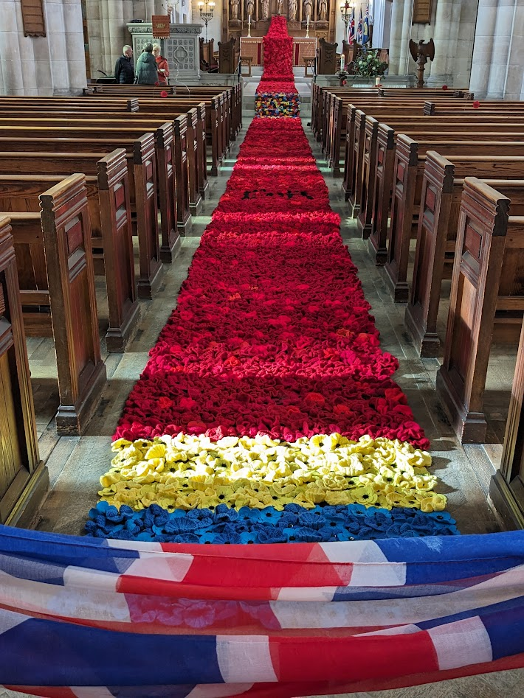
There will be an Act of Remembrance on Monday, 11th November at 10.45 am including a 2 minutes silence at 11.00 am.
Our Remembrance Sunday Service will be on Sunday, 10th November at 10.00 am with the laying of the wreaths and 2 minutes silence at 11.00 am.

The Church will be open to view the Poppy Cascade at the following times:
Saturday, 9th November, 11.00 am to 3.00 pm
Monday, 11th November, 11.00 am to 1.00 pm
A great big thank you to everyone who has made poppies to grow our amazing Poppy Cascade. Also to all those who have sewn the poppies onto the backing material so they can be displayed so well.
The variety of the poppies is amazing, each unique to it’s maker just as we are all unique in God’s eyes. Then brought together as a whole to make something powerful and even more effective just as we, as a community of Christ, are more powerful when working together.
A fitting tribute to all those who have served our country in the two world wars, in all the conflicts since and during the Covid pandemic and for the sacrifice made by those who died. We are also remembering all those who are serving and making many sacrifices in the defence of Ukraine, the Middle East and all the other conflicts around the world. We pray for Peace throughout the world.

A happy story to tell………

Pam Jackson aged 85,
a long time member of St Nicholas's congregation was enjoying the holiday of a lifetime last month when her three grandchildren:
Sam, Annie and Adam together with his wife Sian took her on a Norwegian cruise.

The journey began with a trip to Newcastle to board the Fred Olsen ship Balmoral.
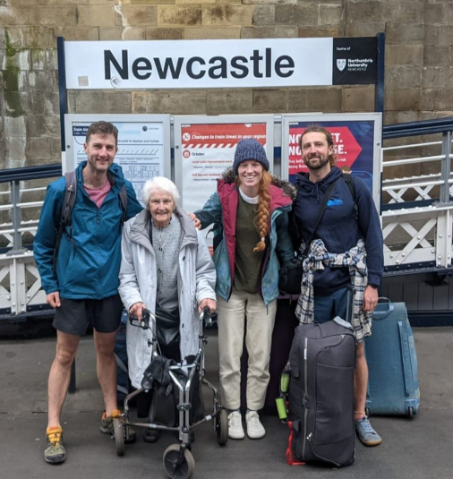
Once at the dock Pam put her walker to good use and had no problem boarding the ship.


Pam, who was a teacher at St George's Primary School, had always dreamed of seeing The Northern Lights so her grandchildren organised the trip to make her dream come true!

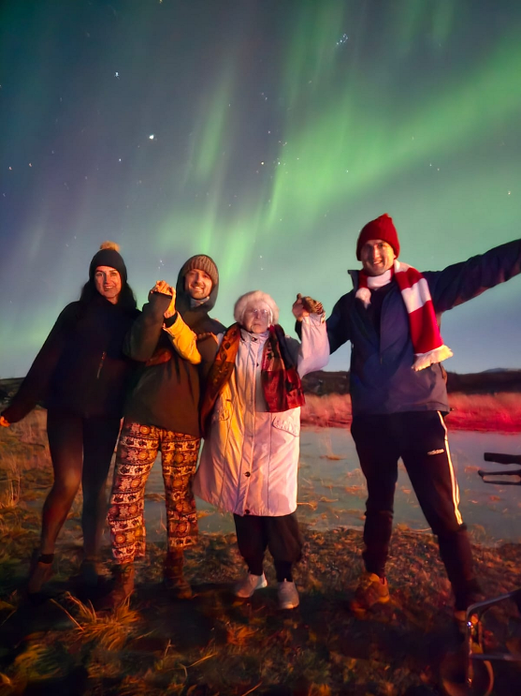
It wasn't just the evenings that were awesome. Each morning
Pam woke, looked at the beautiful scenery surrounding her and asked herself "Have I gone to Heaven?"
Glad you had a fabulous time Pam. You are truly blessed.

Editors note:
Do you have any good news story’s to tell? If so please share them with us.

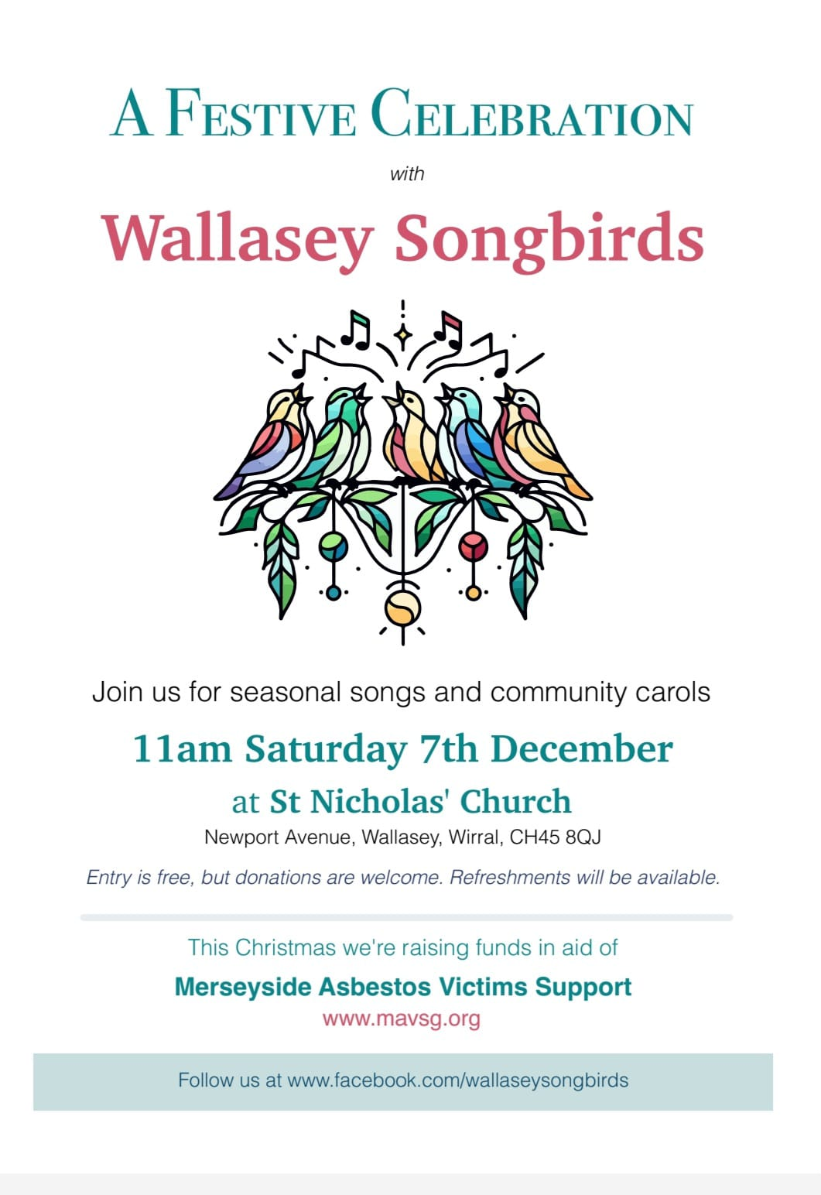
High Days and Holy Days
1 The first martyrs – the ‘seed’ of the Christian Church
The first martyrs of Rome are recorded in the old Roman Martyrology, which states that:
‘At Rome, the birthday is celebrated of very many martyrs, who under the Emperor Nero were falsely charged with the burning of the city and by him were ordered to be slain by various kinds of cruel death; some were covered with the skin of wild beasts, and cast to the dogs to be torn asunder; others were crucified, and then when daylight failed used as torches to illuminate the night. All these were disciples of the apostles and the first fruits of the martyrs whom the Holy Roman Church sent to their Lord before the apostles’ death.’
The poppies of Remembrance

In late 1914, WW1 erupted across Northern France and Flanders. Great swathes of previously green fields and forests were blasted and bombed, leaving them bleak and barren, with seemingly every living thing destroyed.
But then in the Spring of 1915, something beautiful began to come out of all the destruction. Tens of thousands of bright red Flanders poppies began to put out tentative shoots across the endless vistas of mud. These resilient little flowers had actually flourished in the middle of so much chaos and destruction, because their seeds grow when exposed to sunlight, through disturbances to soil.
We all know that these endless fields of cheerful poppies, growing in the midst of such misery and destruction, were what inspired the Canadian doctor, Lieutenant Colonel John McCrae, to write the now famous poem 'In Flanders Fields'.
And it was McCrae’s poem which inspired an American academic named Moina Michael to adopt the poppy in memory of those who had fallen in the war. She got it adopted as an official symbol of Remembrance across the United States, and worked with others who were trying to do the same in Canada, Australia, and the UK.
A French woman, Anna Guérin who was in the UK in 1921, caught the same vision, and planned to sell the poppies in London. There she met Earl Haig, the founder of the Royal British Legion, who was persuaded to adopt the poppy as its emblem in the UK.
The Royal British Legion, which had been formed in 1921, ordered nine million poppies and sold them on 11 November that year. Ever since then, the red poppy has been a symbol of Remembrance, of support for the Armed Forces community, and also of hope for a peaceful future.

16th November St Margaret of Scotland
Some women have power, and some women are good. When a woman with power is also good, she can achieve an astonishing amount.
Margaret of Scotland has been called ‘The Pearl of Scotland’, but she began life in Hungary about 1045. She was born to the expatriate English prince Edward the Exile, and so was an English princess. The family returned to Wessex in 1057, when she was 13, and following the death of King Harold II at the Battle of Hastings in 1066, her brother Edgar Aetheling should have been King of England, but he was never crowned. Instead, the family fled north, to Scotland, where she was married to Malcolm III of Scotland by 1070. As a Scottish queen she went on to become mother of three kings of Scotland, and of a queen consort of England.

Margaret was a Christian, and became a good friend of Lanfranc, a future archbishop of Canterbury. Her biographer tells of how she read narratives from the Bible to her husband, thus helping to ‘civilise’ him. He was illiterate, but so admired her reading, that he had her books decorated with gold and silver. She was also credited with helping her youngest son, the future King David I of Scotland, towards becoming a just and holy ruler.
Margaret introduced the worship and practise of the Church of Rome into Scotland. She also wanted to help the many pilgrims travelling in Scotland, and so she established a ferry across the Firth of Forth, which is where the towns South Queensferry and North Queensferry got their names.
Margaret performed many charitable works for the poor, and she interceded for the release of English exiles who had been forced into serfdom following the Norman conquest. She also began the restoration of Iona Abbey.
In private life, Margaret spent much of her time in prayer, using a cave on the banks of the Tower Burn in Dunfermline as a place of devotion and prayers. St Margaret’s Cave is still there today, covered beneath a municipal car park.
Margaret died in 1093, and in 1250 Pope Innocent IV canonised her. Her relics were dispersed after the Scottish Reformation, but at one time Mary, Queen of Scots, owned her head.

24TH Sunday of Christ the King
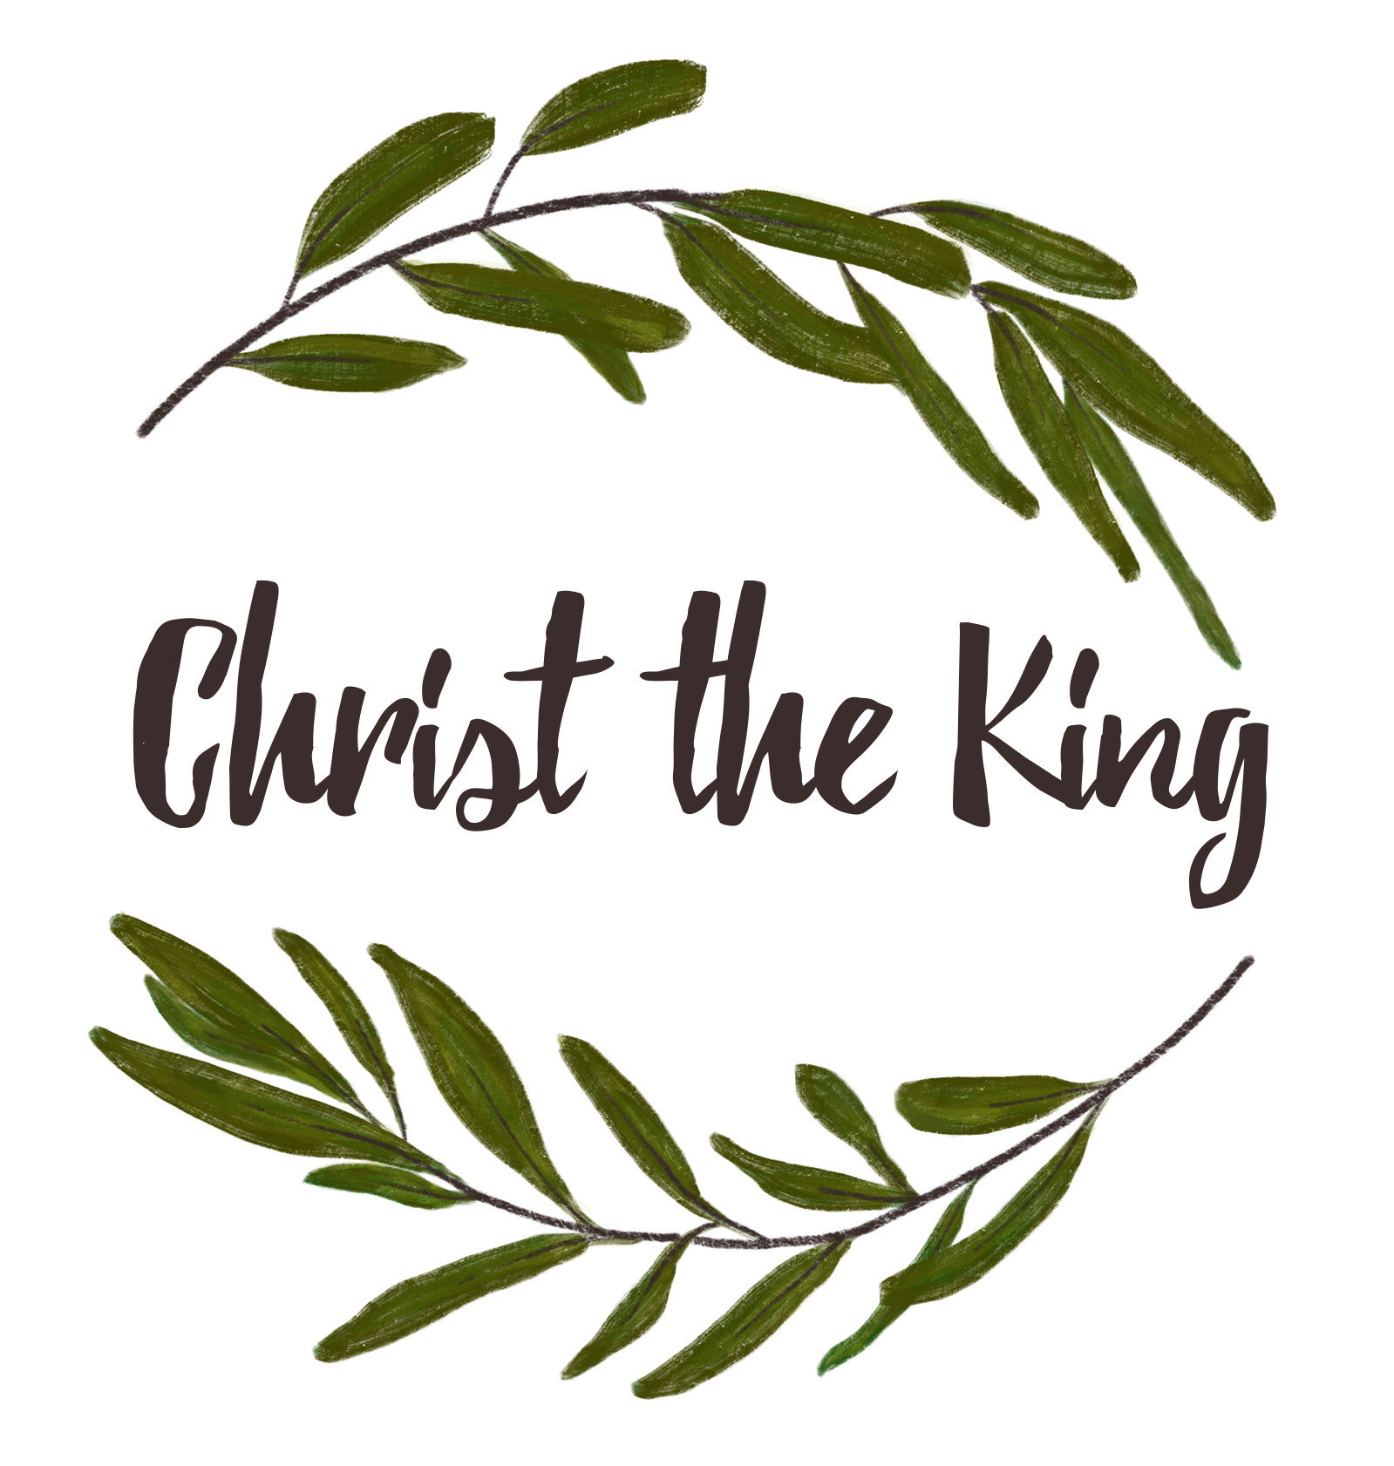
The last Sunday in November is the last Sunday of the church year, and in some ways the most important. Why? Because everything else in the Christian year looks BACK on what happened 2000 years ago. The Sunday of Christ the King looks FORWARD to what we can expect next…. the return one day of Jesus Christ to this earth, as King of Kings.
Does the idea of Jesus of Nazareth literally returning to earth seem a bit quaint to accept, in our computerised world of e-mails and the internet? Well, that is what the Bible says will happen – it is promised more than 250 times!
The Bible is quite clear: the return of the Lord Jesus Christ as King of Kings will take place personally, powerfully, bodily, visibly, publicly – and INSTANTLY. (Read Matthew 24:30,31, or I Thessalonians 4:13 – 5:3.) Here are words of Jesus Himself:
For the Son of Man in his day will be like the lightning, which flashes and lights up the sky from one end to the other. (Luke 17:24)
This will be no local story for a BBC TV reporter to cover if he gets time. That day he won’t be interviewing the Carpenter of Nazareth, wearing Galilean homespun. Jesus will be in His incandescent brilliance as the ‘Son of Man’ – a bit of a challenge even for TV reporters! Certainly, when Peter, James and John were witness to their familiar Master ‘transfigured’, as the same irradiated Person – in a dramatic preview of Christ’s triumphant final rule (Luke 9:28-36), they did not feel very confident.
The martyred Stephen, about to die, had a similar glimpse: “Behold I see the heavens opened, and the Son of Man standing at the right hand of God’ (Acts 7:56). The exiled apostle John on the island of Patmos saw the same figure: ‘…His face was like the sun shining in full strength’ (Revelation 1:16.)
When Christ one day returns, the whole world will finally witness this same spectacle (Revelation 1:7). His return will mark the end of history, as we know it. It will inaugurate the final Judgment. It will re-unite the Lord with His Church on earth.
Jesus’ return to us will bring about the new heaven and the new earth. Pain, death, persecution, privation and sorrow will all be banished. The entire edifice of evil that has raised itself against the rule of God will be dismantled in a moment.
We have been warned all along not to place a date or a time upon the Second Coming of Christ. (Matthew 24:42-44) Sadly, many people ignore this warning and waste endless time in calculations. The way in which we should be spending our days before the end is to work, watch and witness to our Lord Jesus – whether or not ours is a world of computers, e-mail and all the rest!
In the meantime, where is Jesus now? The Bible writers tells us that Jesus has returned to the place of privilege and power, and is ‘seated at the right hand’ of the Father (Ephesians 1:20-21; Colossians 3:1; Hebrews 1:3), and is waiting for the Father’s timing for Him to return to earth in glory (Mark 13:26-27,32), to raise the dead (1 Thessalonians 4:13-18), and give them their resurrection bodies (1 Corinthians 15:35-44).
Jesus will never be a baby again. He is now Christ the King – today, tomorrow, forever.

Looking at God
Reflecting Faith: Wall paintings
Prior to the Reformation, English churches were highly decorated with interior wall paintings. As one author wrote, ‘They were aglow with colour and images covering every flat surface’.
Painting pictures seems to be a basic part of people. We see that in newly discovered caves where people from the distant past have made sketches and created art works.
Pictures are more than just communicating a ‘flat’ story.
Just as we all have our preferred ways of learning – listening, watching, reading, practising – so I suspect we also have for explaining. How much more so, then, when we want to get across really important information; and it doesn’t get much more serious than telling others about God.
Of course, we know the Early Church, at the very beginning, followed the Jewish tradition of not drawing a likeness of God and hence they used signs and symbols. But that didn’t stop them from drawing pictures about everything else: stories from the Bible, lives of the saints, and so on. There was no shortage of pictures to be drawn.
There are not many English churches which still have wall paintings, but if you visit an Orthodox church in the UK or if you get the opportunity to enter one when on the Continent, you will see that every inch (centimetre) of the inside plaster is likely to be covered in wall paintings. Quite literally, painting on the wall!
Today, instead of painting on the wall in the UK, we seem to be increasing the number of banners that hang on them, and changing them often, to match the church calendar.
This month: Have a look at the wall paintings or banners in your own or a different church. What do you think the designers were trying to say? What message do they give you that words alone could not have accomplished?
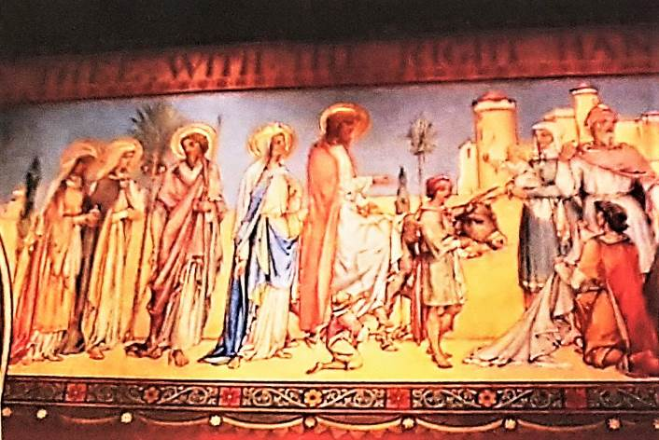
HYMN: The story behind ‘To God be the Glory!’
Fanny Crosby (1820 – 1915), the American singer and musician, was blind from the age of six weeks. She married her music teacher, Alexander Van Alstyne, who was also blind. She was a prolific songwriter, and once signed a contract with a publisher to write three songs every week throughout the year. But in fact, she wrote thousands during her lifetime.
Although American evangelists Moody and Sankey used this hymn on their missions, it did not become an immediate favourite. But after Billy Graham featured it in his Harringay crusade in 1954, Londoners were soon singing it on their way home, in streets and busy queues and underground trains.
When Dr Graham took it back to the United States and introduced it at his crusade in Nashville, Tennessee, it soon took its place in the group of top favourites hymns.

To God Be the Glory
To God be the glory, great things He hath done,
So loved He the world that He gave us His Son,
Who yielded His life our redemption to win,
And opened the life-gate that all may go in.
Praise the Lord, praise the Lord,
Let the earth hear His voice;
Praise the Lord, praise the Lord,
Let the people rejoice;
Oh, come to the Father, through Jesus the Son,
And give Him the glory; great things He hath done.
Oh, perfect redemption, the purchase of blood,
To every believer the promise of God;
The vilest offender who truly believes,
That moment from Jesus a pardon receives.
Great things He hath taught us, great things He hath done,
And great our rejoicing through Jesus the Son;
But purer, and higher, and greater will be
Our wonder, our transport when Jesus we see.
By Fanny Crosby (1820 – 1915)

Looking at You
Something for night owls to consider

If you are a night owl, then this is not good news: recent research has found that those of us who prefer a late bedtime also tend to have a higher body mass index (BMI), larger waists and be almost 50 per cent more likely to develop Type 2 diabetes.
Previous studies that found a link between late nights and Type 2 diabetes put the blame on unhealthy habits such as eating junk food. But now scientists in the Netherlands say that it may be the late nights themselves which are the problem.
Lead researcher Dr Jeroen van der Velde, of Leiden University Medical Centre, in the Netherlands, explained: “A likely explanation is that the circadian rhythm or body clock in late chronotypes is out of sync with the work and social schedules followed by society. This can lead to circadian misalignment, which we know can lead to metabolic disturbances and ultimately Type 2 diabetes.”
A solution? The scientists suggested that night owls might benefit from either going to bed earlier, or in having their last meal of the day earlier.
In the meantime, the Psalmist made the most of being awake in the night, for he wrote: ‘On my bed I remember You; I think of You through the watches of the night.’ (Ps 63.6) Also, ‘I will praise the Lord, who counsels me; even at night my heart instructs me.’ (Ps 16.7)

The key to longer life? Keep calm and carry on
Scientists have long known that mental resilience, or our ability to bounce back in the face of trouble and adversity, has a powerful effect on us for the good. Such resilience has been linked to preventing disease, keeping chronic illnesses at bay, and helping us recover after trauma.
Now it seems that our capacity to cope with and adapt to challenging life events may even delay our risk of dying for many years.
Scientists at the University of Sun Yat-sen, in Shenzhen China, have done extensive research into the health records of more than 10,000 Americans who had signed up for the US Health and Retirement Study. They found that those who scored high on qualities such as perseverance, calmness, a sense of purpose, self-reliance and stoicism had a much lower death rate than others who scored lower.
Writing in the journal BMJ Mental Health, the authors said: “Exposure to adversity, such as poverty or significant life events like job loss or bereavement, often leads to disruptions in psychological functioning. However, individuals differ in their ability to overcome and adapt to adversity, with some exhibiting resilience while others struggle.”
The Bible urges us to not try and cope with life on our own. Instead, it reminds us that God is always our refuge, ‘a very present help in trouble’.
Psalm 55 says: ‘Cast your burden upon the LORD and He will sustain you; He will never allow the righteous to be shaken.’ Now that sounds like resilience - with some heavenly back-up!

Looking at your Community
All in the month of November
It was
250 years ago, on 22 Nov 1774 that Robert Clive, 1st Baron Clive (Clive of India), died. He was the British general who helped found the British Empire in India.
150 years ago, on 23rd Nov 1874 that Thomas Hardy’s novel Far from the Madding Crowd was published. It was his first major success.
125 years ago, from 2nd Nov 1899 to 28 Feb 1900 that the Siege of Ladysmith, a British Colony of Natal, took place. The Boers surrounded the town and cut off the rail link, starving the British defenders. A relief party, which included future British Prime Minister Winston Churchill, arrived on 28th Feb. British victory.
100 years ago, on 2nd Nov 1924 that the first crossword puzzle to appear in a British newspaper was published in the Sunday Express.
Also 100 years ago, on 19th Nov 1924 that Thomas Ince, the ‘Father of the Western’ died. This American silent film producer, director, screenwriter and actor created the first major Hollywood studio, and invented film production.

Also 100 years ago, on 29th Nov 1924 that Giacomo Puccini, Italian composer, died. Known for his operas, including La Boheme, Tosca and Madame Butterfly.
90 years ago, on 30th Nov 1934 that the British steam locomotive, Flying Scotsman, became the first train officially to reach 100 mph.
80 years ago, on 12th Nov 1944 that the British RAF bombed and sank the German battleship Tirpitz, sister ship of the Bizmark, off Norway.
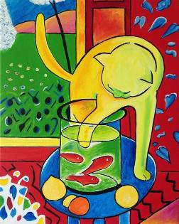
70 years ago, on 3rd Nov 1954 that Henri Matisse died. This French artist was leader of the Fauvist movement and is seen as the most important French painter of the 20th century.
Also 70 years ago, on 13th Nov 1954 that the first Rugby League World Cup Final was held, in Paris, France. Great Britain beat France 16 – 12.
65 years ago, on 1st Nov 1959 that the first stretch of the M1 motorway opened in Britain. Britain’s first motorway service station also opened at Watford Gap.
60 years ago, on 23rd Nov 1964 that the Second Vatican Council allowed the use of vernacular languages (such as English) in Roman Catholic sacraments and rituals, including the Mass. It had insisted on using only Latin for several hundred years. Most people welcomed the change, and the use of Latin quickly dwindled.
50 years ago, on 8th Nov 1974 that British aristocrat Lord Lucan disappeared from his home in London after his children’s nanny was bludgeoned to death and his wife was attacked. There were hundreds of claims of sightings around the world in the following years, but none were substantiated. He was never found and is presumed dead.
Also 50 years ago, on 20th Nov 1974 that British politician John Stonehouse faked his death by leaving a pile of clothing on a beach in Miami, Florida. He was found alive and well in Australia on 24th Dec and was arrested on suspicion of being Lord Lucan.
Also 50 years ago, on 25th Nov 1974 that South African heart surgeon Dr Christian Barnard performed the world’s first double heart transplant. The original heart was left in place and a donor heart was connected to it to support its workload.
40 years ago, on 20th Nov 1984 that SETI (the Search for Extra-Terrestrial Intelligence) was founded in Mountain View, California.
40 years ago, on 25th Nov 1984 that 36 musicians gathered in London to record the Band Aid single Do They Know It’s Christmas to raise money for famine relief in Ethiopia.
30 years ago, on 14th Nov 1994 that the first fare-paying passengers travelled through the Channel Tunnel linking England and France.
Also 30 years ago, on 19th Nov 1994 that Britain’s first National Lottery draw was held.
25 years ago, on 29th Nov 1999 that the Northern Ireland Assembly appointed its first power sharing executive committee.
15 years ago, on 26th Nov 2009 that the Murphy Commission of Inquiry published its damning report on the abuse of children by Roman Catholic priests in Dublin during 1975 - 2004. It was found that church leaders had conspired with the Garda to cover up the abuse.
10 years ago, on 3rd Nov 2014 that the One World Trade Center officially opened in New York City. It replaced the World Trade Center that was destroyed in the 9/11 terrorist attacks in 2001.
Also 10 years ago, on 27th Nov 2014 that P D James, British novelist, died. Best known for her crime novels featuring the detective, Adam Dalgliesh.
Looking at your Church

Closing churches cuts worship numbers, poll finds
‘In person church attendance’ can fall by almost a third (29%) if a local church closes, a new opinion poll has found.
The poll, commissioned by the National Churches Trust, revealed that when a local church closes, 22% of the churchgoers are unwilling or unable to worship in a different church. A further 7% said that they would only attend services online. A further 7% said that they would attend less often than at present.
Churchgoers in the North East and North West of England are the most likely to stop going to church at all (30% and 31% respectively). Those in London are least likely to stop going to church at all (14%).
The poll also found that there is little interest among current church-goers for any alternative style services held in a cafe, community centre, school or a mission hub.
The National Churches Trust points to the increasing cost of repairs and maintenance as a key reason why many churches face closure.
The Trust is calling on the new Government to guarantee the future of the Listed Places of Worship Grants Scheme, which allows churches to claim back the VAT on church repairs, but which is only guaranteed until March 2025.
Claire Walker, Chief Executive of the National Churches Trust, the UK’s church building support charity, explained:
“Many church closures take place as the money cannot be found to carry out urgent repairs. Fixing a roof can cost over half a million pounds. The backlog of repairs for the Church of England’s churches alone is at least £1 billion, and the annual need is estimated to be £150 million a year.”
“Some churches are currently helped by the Listed Places of Worship Grants Scheme, which allows historic churches to claim back the VAT on repairs. But this scheme is due to expire in March 2025.”
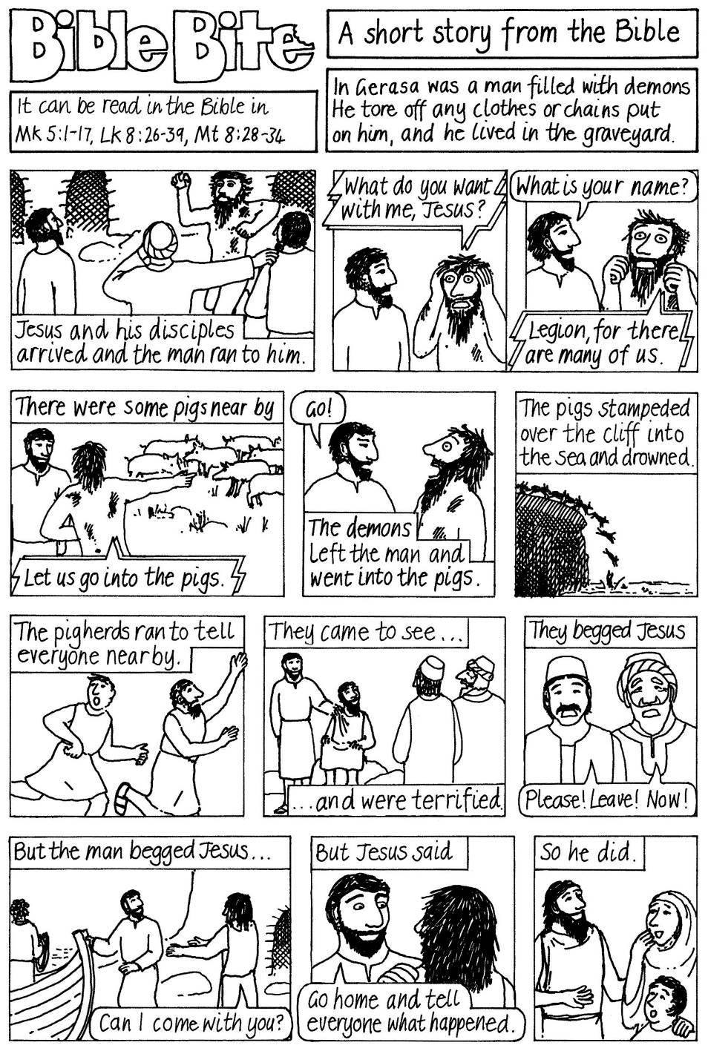

People you may need to contact in St Nicholas Church.

Vicar: Revd Jeff Staples 639 3589
07906067325

Email: stnicholaswallasey@gmail.com
Website: www.stnicholaswallasey.co.uk

Wardens Julie Piercy 364 9543
Elizabeth Brandwood 630 4411
Treasurer: Colin Hazlehurst 0151 923 5044
PCC Secretary: Carol Hankey 07900457680
Musical Director: Gill Hazlehurst 0151 923 5044
Hall Steward: Joyce Boggild 638 7586
Church Flowers: Elizabeth Brandwood 630 4411
Child Protection: Julie Pollitt julespoll4@gmail.com
Parish Office 639 0310.

St Nicholas has a dedicated Safeguarding email address:
safeguardingatstnicholas@gmail.com

The Vicar’s day off is usually Friday.

