**The Parish of Wallasey St Nicholas with All Saints (0711).**

**Safeguarding Policy for children, young people and adults**

**adapted from ‘Promoting a Safer Church**

**The Church of England’s Safeguarding Policy for children, young people* and adults**.’**

**Revised 27th April 2023**

*young people/person” means any individual(s) aged 14 to 17 years old;

**“vulnerable adult” is defined as “person aged 18 or over whose ability to protect himself or herself from violence, abuse, neglect or exploitation is significantly impaired through physical or mental disability or illness, old age, emotional fragility or distress, or otherwise; and for that purpose, the reference to being impaired is to being temporarily or indefinitely impaired…”

We believe that everyone who participates in the life of the Church has a role to play in promoting a Safer Church for all.

Our Safeguarding policy is based the following foundations:

* Gospel

The Church is called to share the good news of God’s salvation through Jesus Christ. The life of our communities and institutions is integral to how we address this task. The good news speaks of welcome for all, with a particular regard for those who are most vulnerable, into a community where the value and dignity of every human being is affirmed and those in positions of responsibility and authority are truly trustworthy. Being faithful to our call to share the gospel.

* Human Rights Law-Core Principals

The PCC and Congregation of St Nicholas Church recognises the personal dignity and rights of all children, young people and adults, as enshrined in the Human Rights Act 1998 and the 1989 United Nations Convention on the Rights of the Child.

**Our Commitment.**

**We will:**

* Act with integrity and respect
* Listen to all,
* Have transparency and be accountable for our actions and decisions
* Be proactive in the management of risk and committed to the prevention of abuse
* Learn from the past
* Be accountable for our actions and decisions
* Collaborate with key statutory authorities and other partners
* Use professional safeguarding advice and support both inside and outside the Church
* Be committed to the prevention of abuse
* Be pro-active in the management of risk
* Promoting a culture of informed vigilance
* Regularly evaluate our policy to ensure best practice.

**We will seek to:**

* Promote a Safer environment and culture
* Support all those with any responsibility related to children, young people and vulnerable adults within the Church
* Respond promptly to every safeguarding concern or allegation
* Care pastorally for victims/survivors of abuse and other affected persons
* Care pastorally for those who are the subject of concerns or allegations of abuse and other affected persons
* Respond to those that may pose a present risk to others.

Our policy applies to all recognised Church groups and any group or individual appointed or elected or is acting on behalf of the PCC of St Nicholas Church to a post or role, whether they are ordained or lay, paid or unpaid.

Groups (via their appointed spokesperson) and individuals have a duty to have ‘due regard’ to report any allegation of abuse which means that the person under the duty is not free to disregard it but is required to follow it unless there are cogent reasons for not doing so.

The Church of St Nicholas, its clergy and leaders and congregation are committed to safeguarding as an integral part of the life and ministry of our Church.

Index

Page 3 Defining Abuse

Page 4 Policy Commitments

Page 6 Appendix 1. Training Programme

Page 8 Appendix 2. Parish Recording Form

Page 15 Appendix 4. Contact details for Children and Adult Services in the Chester Diocese.

Page 16 Appendix 5. What to do if you are concerned about a child or adult and/or you are

concerned that a Church Officer may be abusing a child or adult.

Page 19 Appendix 6. Guidelines for responding to a person disclosing abuse.

Page 22 Appendix 7. Recording, data protection and information sharing.

Page 24 Appendix 8. Safeguarding Provision for the Hire of the Church building of Church

Hall.

**Defining Abuse.**

We recognise abuse as defined in the Church of England Document ‘Fact Sheet: Types of Abuse’ and ‘Parish Safeguarding Handbook’ section 3 ‘Abuse of Children’ and section 4 ‘Abuse and Neglect of Adults.’ A copy of the ‘Parish Safeguarding Handbook’ is available electronically on the St Nicholas Church website <https://www.stnicholaswallasey.co.uk/page/42/safeguarding-st-nicholas-church> and a hard copy is located in the Vicar’s Vestry of St Nicholas Church.

1. **Defining Abuse towards Children.**

Working Together to Safeguard Children 2018 defines abuse as expressed in the document: *A form of maltreatment of a child. Somebody may abuse or neglect a child by inflicting harm or by failing to act to prevent harm. Children may be abused in a family or in an institutional or community setting by those known to them or, more rarely, by others (e.g. via the internet). They may be abused by an adult or adults or another child or children.”* A fuller description of abuse indicators is available in our Safeguarding Policy located in the Vicar’s Vestry at St Nicholas Church.

Child abuse is defined as four categories:

• Physical  
• Sexual  
• Neglect  
• Emotional

**2) Defining Abuse towards Adults**

There are many different types of abuse and they all result in behaviour towards a person that deliberately or intentionally cause harm. It is a violation of an individual’s human and civil rights and in the worst cases can result in death.

The types of abuse are:

* Physical abuse
* Sexual abuse
* Psychological or emotional abuse
* Financial or material abuse
* Modern slavery
* Discriminatory abuse
* Domestic violence or abuse
* Organisational or institutional abuse
* Neglect or acts of omission
* Self-neglect

**Policy Commitments**

Based on the foundations outlined above at St Nicholas church:

1. **We will promote a safer environment and culture.**

* All Church Officers will respect all children, young people and vulnerable adults and promote their well-being.
* This will be done by training, support, communication, learning, governance and quality assurance processes. **See appendix 1**.
* The Church will strive to support all Church Officers
  + to adhere to safer working good practice and
  + to challenge the abuse of power.

1. **We will safely recruit and support all those with any responsibility related to children and vulnerable adults within the Church**

The Church will select and vet all those with any responsibility related to children, young people and vulnerable adults within the Church, in accordance with Section 5 of the Parish Safeguarding Handbook and with the Church of England and Methodist Joint Policy on Safer Recruitment. A copy the Church of England and Methodist Joint Policy on Safer Recruitment Both can be viewed can be viewed on the St Nicholas Church website: <https://www.stnicholaswallasey.co.uk/page/42/safeguarding-st-nicholas-church> or the Chester Diocese website <https://www.chester.anglican.org/support-services/safeguarding/>

1. **We will respond promptly to every safeguarding concern or allegation.**

* Anyone who brings any safeguarding suspicion, concern, knowledge, or allegation of current or non-current abuse to the notice of the Church will be responded to respectfully and in a timely manner, in line with statutory child and adult safeguarding procedures and the House of Bishops safeguarding policy and practice guidance. **Refer to the Parish Safeguarding Handbook.**
* All safeguarding work will be recorded in line with the House of Bishops safeguarding practice guidance. **Refer to the Parish Safeguarding Handbook**.
* All suspicions, concerns, knowledge, or allegations will be reported via the diocesan safeguarding adviser or designated safeguarding adviser/officer in another church body to the appropriate statutory authorities. **See appendix 2.**
* Where there is a concern that a Church Officer is abusing a child, young adult, or adult refer to the **Parish Safeguarding Handbook**.

1. **We will respond, record and report if somebody discloses abuse, including non-recent abuse and domestic abuse.**

* This will be done in accordance with the **Parish Safeguarding Handbook**
* All case file information will be stored as Sensitive Information on the Church Desk software package which is fully GDPR compliant and accessed only by the Vicar. Hard copy reports will be held in a secure location once the PSO has completed the case.

1. **We will care pastorally for victims/survivors of abuse and other affected persons**

Our Church will endeavour to offer care and support to all those that have been abused, regardless of the type of abuse, when or where it occurred. **Refer to section 8 of the Parish Safeguarding Handbook**.

1. **We will care pastorally for those who are the subject of concerns or allegations of abuse and other affected persons**

St Nicholas Church will endeavour to respect the rights under criminal, civil and ecclesiastical law of an accused Church Officer including the clergy. A legal presumption of innocence will be maintained during the statutory and Church inquiry processes.

We will take responsibility for ensuring that steps are taken to protect others when any Church Officer is considered a risk to children, young people, and vulnerable adults.

Church Officers who are the subject of concerns or allegations of abuse belong to families, congregations, and church communities. The Church will be mindful of the need to provide support to members of families, parishes and congregations affected by the Church Officers in such situations.

1. **We will respond carefully and sensitively to those that may pose a present risk to others**

The Church, based on the message of the gospel, opens its doors to all. It will therefore endeavour to offer pastoral care and support to any member of the church community whom may present a known risk. The Church will ensure that any risk has been assessed and is being managed in a safeguarding agreement in accordance with House of Bishops policy and practice guidance. This will be done in collaboration with the relevant statutory agencies in accordance with criminal, civil and ecclesiastical law. See section 10 of the Parish Safeguarding Handbook.

1. **We will ensure an addendum to a hire agreement is always used when any person/body hires church premises. See appendix 3.**

This will apply to both the Church building and the Church Hall (Harrison Memorial Hall) for any activity that involves children, young people, or vulnerable adults, for example a pre-school, youth group or mental health support group.

1. **We will put the policy into action.**

All parts of St Nicholas Church must adopt or take account of this Policy Statement.

The Policy Statement will actively underpin all safeguarding work within our church and drive improvements to our safeguarding practice.

In order to attain this, we will ensure that:

* All Church Officers have access to this Policy Statement
* A shortened ‘at a glance’ version of this Policy Statement will be prepared for the Parish and Diocese and will be available on our website
* A hard copy A4 Policy statement will be available in church for those who do not have access to the internet.
* The Policy Statement will be promoted and publicised in the church magazine and weekly notices

1. **Parish Safeguarding Checklist.** A copy is available online via the St Nicholas website homepage or has a hard copy in the Church.

**Appendix 1**

Training will be in accordance with the Diocesan Training Programme.

https://www.chester.anglican.org/support-services/safeguarding/safeguarding-7485.php

A number of training levels are offered including:

**Basic Awareness**  
This course will connect the core principles and practices of safeguarding to the Christian faith and can be completed by anyone wanting a basic understanding of safeguarding.

Pre-Requisites: None  
Required attendees:  All Church Officers

**Foundation**  
This course builds on the learning gained from the Basic Awareness course and helps to provide an understanding of good safeguarding practice in relation to your role and responsibilities.

Pre-Requisites: Basic Awareness course.  
Required attendees:

* Anyone holding the Bishop's licence, commission, authorisation, or permission (clergy, PtO, Readers, LLMs).
* Anyone in a role which involves work with children, young people, or vulnerable adults.
* Churchwardens.
* Vergers.
* PCC members / Lay Chapter members.

**Leadership**  
The Leadership Pathway is about leadership and cultural change and hence the people who participate should be **those who play a lead role in shaping the culture of their Church body**.

Pre-Requisites: Basic Awareness & Foundation courses. There is mandatory pre-course work to complete and return in the three weeks leading up to the commencement of the course.

Required attendees:

* All clergy holding the Bishop’s licence, commission, authorisation, or permission ( can include PtO if their role meets leadership criteria)
* All readers and Licensed Lay Ministers holding the Bishop's Licence (can include PtO if their role meets leadership criteria)
* Safeguarding Officers / Leads in all Church bodies

**Parish Safeguarding Officer Training**  
This course will equip newly appointed PSOs with an understanding of the role and induct them into key working practices and relationships. It is also suitable for existing PSOs wanting to refresh their knowledge.

Pre-Requisites: Basic Awareness, Foundation and Leadership courses. There is some reading to complete prior to the course.

Required attendees:

* Persons taking on the role of Parish Safeguarding Officer.

**Raising Awareness of Domestic Abuse**  
This course will equip participants to engage thoughtfully and proactively with the issue of domestic abuse and those affected.

**Pre-Requisites: Basic and Foundation courses.**

**Required attendees:**

* **Anyone holding the Bishop's licence, commission, authorisation or permission (clergy, PtO, Readers, LLMs).**
* **Pastoral Visitors.**
* **Safeguarding Officers.**
* **PCC Members / Lay Chapter Members.**

**Safer Recruitment & People Management**

This course will equip participants with an understanding of safer recruitment and the skills and practices necessary to promote positive safeguarding behaviour (and detect safeguarding risk) once a person is in role.

**Pre-Requisites: Basic and Foundation courses.**

**Required attendees:**

* Line Managers and anyone involved in the recruitment of Church Officers (employees, elected members and volunteers)
* Those with responsibility for administering DBS
* Safeguarding Officers in all Church bodies
* Ordinands during IME 1

**Appendix 2**

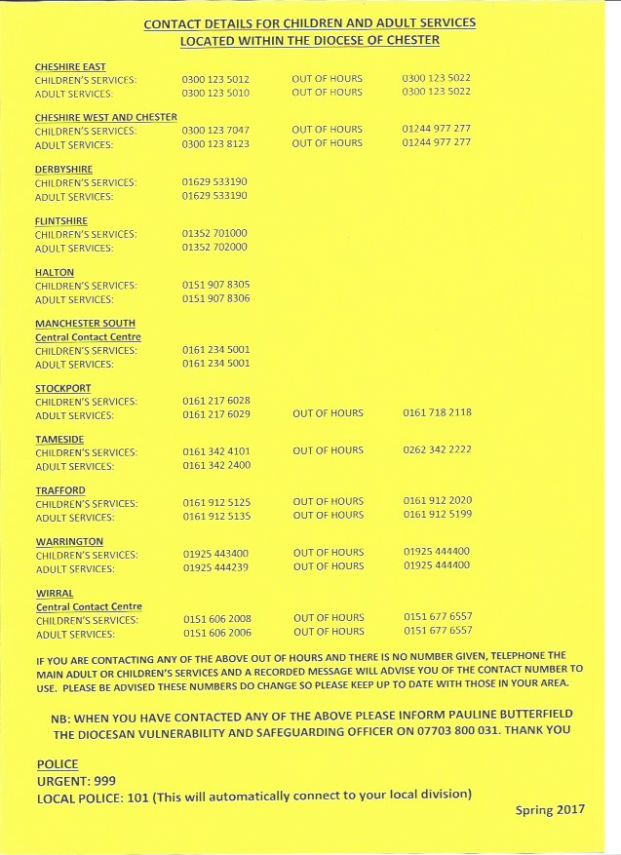

**Appendix 3.**

**Safeguarding Provision that can be attached to any Hire of Church Premises Agreement**

**The Parochial Church Council of St Nicholas Parish Church has a Policy for Safeguarding Children, Young People and Vulnerable Adults. A copy of the Policy Guide is attached. Your booking agreement is conditional upon you complying with it unless you already have an equivalent policy of your own.**

**You are required to ensure that children, young people and vulnerable adults are protected at all times, by taking all reasonable steps to prevent injury, illness, loss or damage occurring; and that you carry full liability insurance for this.**

**In particular this means that:**

* you will comply with the attached good practice guide with children and young people or vulnerable adults unless you already have an equivalent;
* you will provide the church with a copy of your organisation’s Safeguarding Policy/ies or if you do not have one adopt the current parish policy;
* you will recruit safely all current paid and voluntary workers who work with children and/or vulnerable adults, by obtaining satisfactory disclosures from the Disclosure and Barring Service where eligible, and keeping records of dates and disclosure numbers indefinitely;
* you will keep a list of the names of all paid and voluntary workers with regular and direct contact with children/vulnerable adults , and update it annually;
* you will always have at least two leaders over the age of 18 years in any group of children and young people, no matter how small the group;
* no person under the age of 18 years will be left in charge of any children or young people of any age;
* no child or group of children or young people should be left unattended at any time;
* a register of children, young people or vulnerable adults attending the activity will be kept securely. This will include details of their name, contact details of parent/guardian/carer etc., date of birth and next of kin;
* you will immediately (within 24 hours) inform the Parish Safeguarding Officer of:
* (a) the occurrence of any incidents or allegations of abuse or causes of concern relating to members or leaders of your organisation, and contact details for the person in your organisation who is dealing with it
* (b) any known offenders against children or vulnerable adults seeking to join your membership, and manage such allegations or agreements with offenders in co-operation with statutory agencies, and with the church.

**The Parish Safeguarding Officer for St Nicholas Church Julie Pollitt. Email address: safeguardingatstnicholas@gmail.com**

**Declaration**

**I agree to abide by appropriate safeguarding procedures. I understand that my booking agreement may be terminated in the event of my failing to comply with these procedures.**

**Signed ………………………………………………… Designation ……………………………**

**Organisation ………………………………………….. Date ……………………………………**

**(Please sign two copies, one to be retained by the church, and one by the organisation)**